

|  |
| --- |
| Group 3: Jumpy Jumpy Man |
| **Game Design Document**  Version #1.0 |
| Alejandro, Pintado Munoz (3xxxxxxxx) |
| Jin, Huang (301020707) |
| Michel, Daoud (301276345) |
| Sabeeh, Sabeeh (301184564) |
| Solaleh, Taheri (301306072) |
| Yuk Sing, Cheung (301230209) |

|  |
| --- |
| Jan 23th, 2023 |

**Table of Contents**

Version History 3

I. Game Type 4

II. MDA 4

III. Controls. 4

V. Screen Captures 8

VI. Characters/ Vehicles/ Camera 8

VII. Enemies (AI) 9

VIII. Weapons 9

IX. Sound Index 10

X. Art / Multimedia Index 10

# Version History

|  |  |  |  |
| --- | --- | --- | --- |
| **Name** | **Date** | **Reason For Changes** | **Version** |
| Initial GDD | Jan 25, 2023 | Creation of the initial GDD with concept and assets for platformer game | 1.0 |

# Game Type & Concept

Platform Runner is selected.

# 

# MDA

**Mechanics:**

The game mechanics in our 3D platformer involve jumping, running, and other movement based on powerups. The player must navigate through various levels, defeating hazards and collecting power-ups along the way. The player has a health bar that decreases when taking damage and can be replenished by collecting health pickups. The player can also collect coins and other items to increase their score.

**Dynamics:**

The dynamics of the game involves the player's interactions with the environment and enemies. As the player progresses through the levels, they will encounter various obstacles and enemies that they must overcome. The player must also manage their health. The game features a variety of different hazards, each with their own unique abilities and behaviors.

**Aesthetics:**

The aesthetic of the game is designed to be whimsical and colorful. The game features lush 3D environments, with bright and vibrant colors. The characters and enemies are designed to be cartoonish and expressive, adding to the light-hearted and fun atmosphere of the game. The game also features *a catchy and upbeat soundtrack that adds to the overall aesthetic experience.*

# Controls.

The game will be controlled using a combination of keyboard and mouse input. The specific input scheme is as follows:

**Keyboard:**

* W, A, S, D or arrow keys to move the character
* Spacebar to jump (x2 to double jump with power-up)
* Shift to run/dodge (with powerup)
* CTRL to crouch

**Mouse:**

* Move to look around
* Scroll wheel to zoom in/out

1. **Levels and UI Sketch**

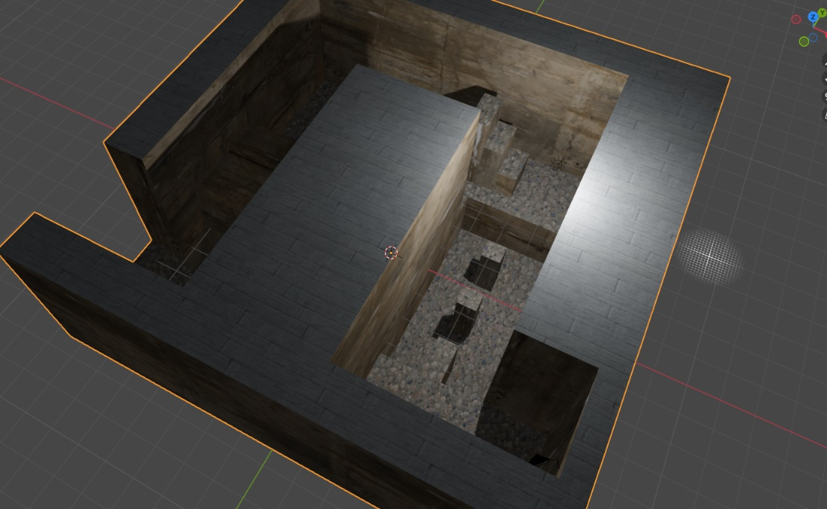

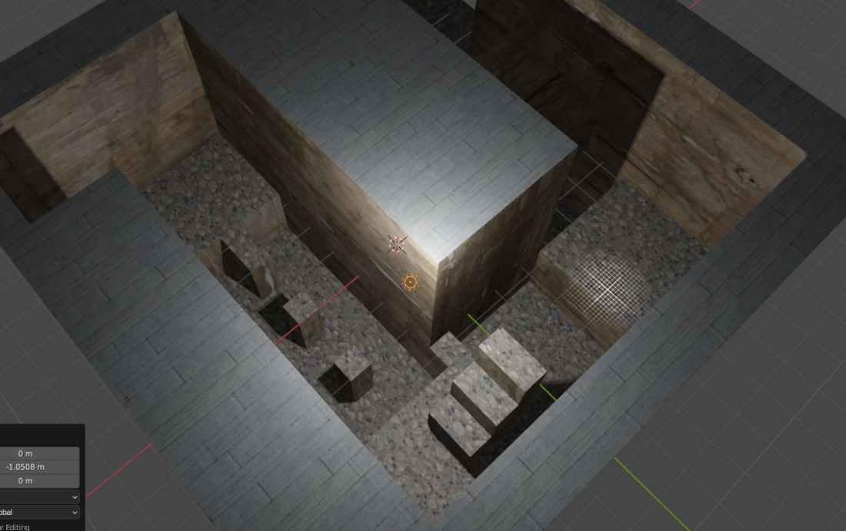

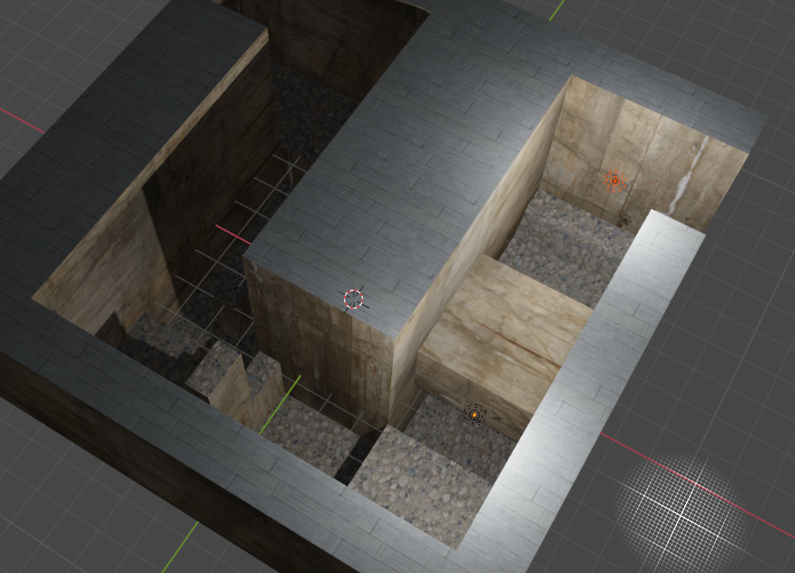

# Screen Captures (Later versions)

# Characters/ Vehicles/ Camera

The controls for the character are as follows:

* W, A, S, D or arrow keys to move the character
* Spacebar to jump (x2 to double jump with power-up)
* Shift to run/dodge (with powerup)
* CTRL to crouch

The character also can use power-ups such as wall running, double jumping, and dodging. These power-ups can be found scattered throughout the levels or obtained from defeated enemies.

The camera follows the character's movement and can be controlled using the mouse. Player can use the mouse to look around.

The desired behavior for the character is to provide the player with a strong sense of immersion and control, allowing them to fully engage with the game world. The character's abilities and power-ups are designed to provide the player with new options and strategies, making the gameplay more exciting.

# Enemies (AI)

The game features various computer-controlled hazards, that the player must contend with. These hazards have unique behaviors and abilities that the player must learn to overcome.

* **Spinning Hazards:** These hazards rotate rapidly on a fixed axis. They damage player if they meet them. The spinning hazards move in a set pattern, and the player must manage their time to avoid them.
* **Disappearing Hazards:** These hazards will appear and disappear at regular intervals. They are invulnerable while they are invisible but can be seen when they appear. The player must pay attention to their surroundings and anticipate the hazards' movements to avoid them.
* **Shattering Hazards:** These hazards are fragile and will break if being stood on for too long. The player must quickly move across these hazards to avoid falling through and taking damage.
* **Moving Hazards:** These hazards move along a set path, and the player must navigate around them to avoid collision. These hazards can be either slow or fast-moving, and the player must adjust their movements accordingly.

All hazards are designed to be challenging but fair, providing a sense of accomplishment when the player overcomes them. The desired behavior for these hazards is to increase the level of difficulty and engagement for the player.

# Weapons

In our 3D platformer, the player has access to a variety of power-ups that grant them some special abilities to be an aid in their journey. These power-ups can be found scattered throughout the levels or obtained from defeated enemies.

* Wall Running: This power-up allows the player to run up walls for a limited time. This allows the player to reach new areas and overcome obstacles that were previously out of reach.
* Double Jump: This power-up allows the player to perform a second jump while in mid-air. This allows the player to reach higher platforms and navigate the levels with greater ease.
* Dodge: This power-up allows the player to perform a quick dodge move, allowing them to avoid enemy attacks and navigate through tight spaces.

Each power-up has a limited duration and can only be used in certain amount of time before it needs to be collected again. The desired behavior for these power-ups is to provide the player with new abilities and options, making the gameplay more dynamic and exciting.

# Sound Index

*We will be using multiple sounds from unity store such as monster sounds, pounch and fighting sounds, Grenade sounds ,etc.*

# Art / Multimedia Index

*We will be using plenty of bridge(quixel) assets such as common textures but the whole characters, environment, etc. is designed by us.*